**Open Ended Problem**

Develop an object oriented system “Visiting Card Management” which allows user to add, delete and update and search the visiting card details.

#include<fstream.h>

#include<iostream.h>

#include<ctype.h>

#include<iomanip.h>

#include<conio.h>

#include<stdio.h>

class account

{

int id;

char name[50];

char address[100];

char occupation[30];

char contact[18];

char email[50];

public:

void create(); //function to get data from user

void show(); //function to show data on screen

void modify(); //function to get new data from user

void report(); //function to show all data

int retid(); //function to return ID

};

void account::create()

{

cout<<"\nID. :";

cin>>id;

cout<<"\n\nEnter your Name : ";

gets(name);

cout<<"\nEnter your Occupation : ";

gets(occupation);

cout<<"\nEnter the Address for visiting card : ";

gets(address);

cout<<"\nEnter Contact Number : ";

gets(contact);

cout<<"\nEnter Email ID : ";

gets(email);

cout<<"\n\n\nAccount Created..";

}

void account::show()

{

cout<<"\nID. : "<<id;

cout<<"\nName : ";

cout<<name;

cout<<"\nOccupation : "<<occupation;

cout<<"\nAddress : "<<address;

cout<<"\nContact : "<<contact;

cout<<"\nEmail ID : "<<email;

}

void account::modify()

{

cout<<"\nID. :";

cin>>id;

cout<<"\n\nEnter your Name : ";

gets(name);

cout<<"\nEnter your Occupation : ";

gets(occupation);

cout<<"\nEnter the Address for visiting card : ";

gets(address);

cout<<"\nEnter Contact Number : ";

gets(contact);

cout<<"\nEnter Email ID : ";

gets(email);

cout<<"\n\n\nAccount Modified..";

}

void account::report()

{

cout<<id<<setw(7)<<" "<<name<<setw(10)<<" "<<occupation<<endl;

}

int account::retid()

{

return id;

}

void write_file(); //function to write record in binary file

void display(int); //function to display account details given by user

void modify_file(int); //function to modify record of file

void delete_file(int); //function to delete record of file

void display_all(); //function to display all account details

void intro(); //introductory screen function

int main()

{

int ch;

int num;

clrscr();

intro();

do

{

clrscr();

cout<<"\n\n\n\tMAIN MENU";

cout<<"\n\n\t01. NEW VISITING CARD";

cout<<"\n\n\t02. ALL CARD HOLDER LIST";

cout<<"\n\n\t03. DELETE CARD";

cout<<"\n\n\t04. MODIFY VISITING CARD";

cout<<"\n\n\t05. SHOW DETAIL OF VISITING CARD";

cout<<"\n\n\t06. EXIT";

cout<<"\n\n\tSelect Your Option (1-6) ";

cin>>ch;

clrscr();

switch(ch)

{

case 1:

write_file();

cout<<"\nDO REMEBER YOUR VISITING CARD ID!";

break;

case 2:

display_all();

break;

case 3:

cout<<"\n\n\tEnter unique ID. : "; cin>>num;

delete_file(num);

break;

case 4:

cout<<"\n\n\tEnter Unique ID. : "; cin>>num;

modify_file(num);

break;

case 5:

cout<<"\n\n\tEnter The account No. : "; cin>>num;

display(num);

break;

case 6:

cout<<"\n\n\tThanks for using Visting card managemnt system";

break;

default :cout<<"\a";

}

getch();

}while(ch!=6);

return 0;

}

void write_file()

{

account ac;

ofstream outFile;

outFile.open("visting.txt",ios::binary|ios::app);

ac.create();

outFile.write((char *) &ac, sizeof(account));

outFile.close();

}

void display(int n)

{

account ac;

int flag=0;

ifstream inFile;

inFile.open("visting.txt",ios::binary);

if(!inFile)

{

cout<<"File could not be open !! Press any Key...";

return;

}

cout<<"\n******************VISITING CARD******************\n";

while(inFile.read((char *) &ac, sizeof(account)))

{

if(ac.retid()==n)

{

ac.show();

flag=1;

}

}

inFile.close();

if(flag==0)

cout<<"\n\nAccount number does not exist";

}

void modify_file(int n)

{

int found=0;

account ac;

fstream File;

File.open("visting.txt",ios::binary|ios::in|ios::out);

if(!File)

{

cout<<"File could not be open !! Press any Key...";

return;

}

File.seekg(0,ios::beg);

while(File.read((char *) &ac, sizeof(account)) && found==0)

{

if(ac.retid()==n)

{

ac.show();

cout<<"\n\nEnter The New Details of account"<<endl;

ac.modify();

int pos=(-1)*sizeof(account);

File.seekp(pos,ios::cur);

File.write((char *) &ac, sizeof(account));

cout<<"\n\n\t Record Updated";

found=1;

}

}

File.close();

if(found==0)

cout<<"\n\n Record Not Found ";

}

void delete_file(int n)

{

account ac;

ifstream inFile;

ofstream outFile;

inFile.open("visting.txt",ios::binary);

if(!inFile)

{

cout<<"File could not be open !! Press any Key...";

return;

}

outFile.open("Temp.txt",ios::binary);

inFile.seekg(0,ios::beg);

while(inFile.read((char *) &ac, sizeof(account)))

{

if(ac.retid()!=n)

{

outFile.write((char *) &ac, sizeof(account));

}

}

inFile.close();

outFile.close();

remove("visting.txt");

rename("Temp.txt","visting.txt");

cout<<"\n\n\tRecord Deleted ..";

}

void display_all()

{

account ac;

ifstream inFile;

inFile.open("visting.txt",ios::binary);

if(!inFile)

{

cout<<"File could not be open !! Press any Key...";

return;

}

cout<<"\n\n\t\tVISITING CARD LIST\n\n";

cout<<"===============================================================\n";

cout<<"ID"<<setw(8)<<" "<<"NAME"<<setw(15)<<" "<<"OCCUPATION"<<endl;

cout<<"===============================================================\n";

while(inFile.read((char *) &ac, sizeof(account)))

{

ac.report();

}

inFile.close();

}

void intro()

{

cout<<"\n\n\n\t\t\t VISITING CARD";

cout<<"\n\n\t\t MANAGEMENT\n";

cout<<" \t\t SYSTEM";

getch();

}

**Output:**

Add User

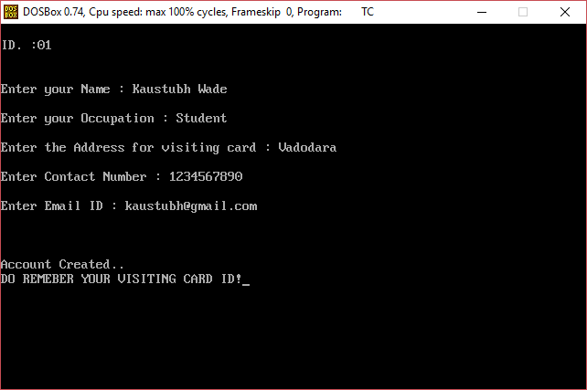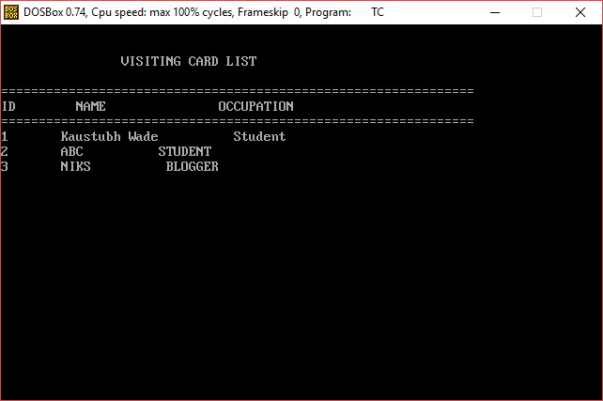

Delete User

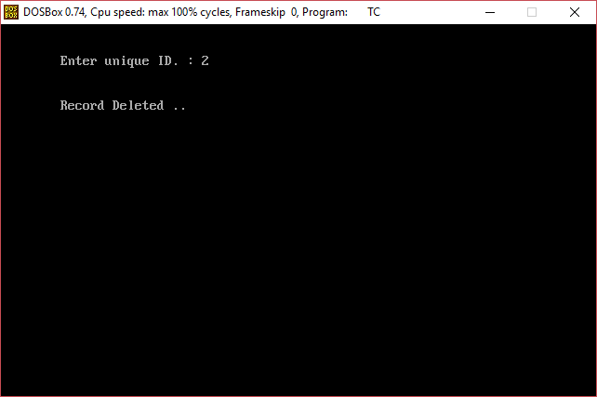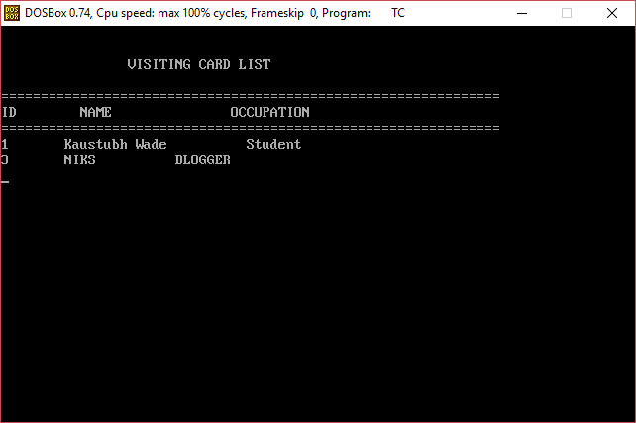

Update User

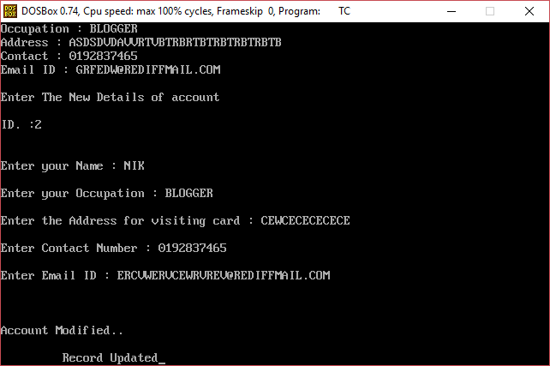

Search User

